The Protocol
The Structure
1.Length Field: Every message starts with 4 numbers. These numbers tell us how many characters are in the rest of the message (e.g., 0012 means 12 more chars coming).
2.The Content (Payload): After the numbers, we have the actual data, split into 3 parts using the separator #@
3. Time Field: This part appears right after the command name and the separator. It is a number that tells the server exactly when the message was created, using a standard Unix timestamp format (e.g., 173230000 represents the time in seconds).
Example of what it looks like in the code: 0024DIR#@173230000#@C:\Windows
How the Photo Transfer Works (SEND_PHOTO)
This is the only tricky part. When we want to get the image, it happens in steps:
1.Server checks if the file exists.
2.It sends a protocol message with the file size (TYPE=FILE, DATA=SIZE).
3.Right after that, it sends the actual raw bytes
of the image (no protocol stuff here, just data).
4.When done, it sends a final text message
saying it finished successfully.

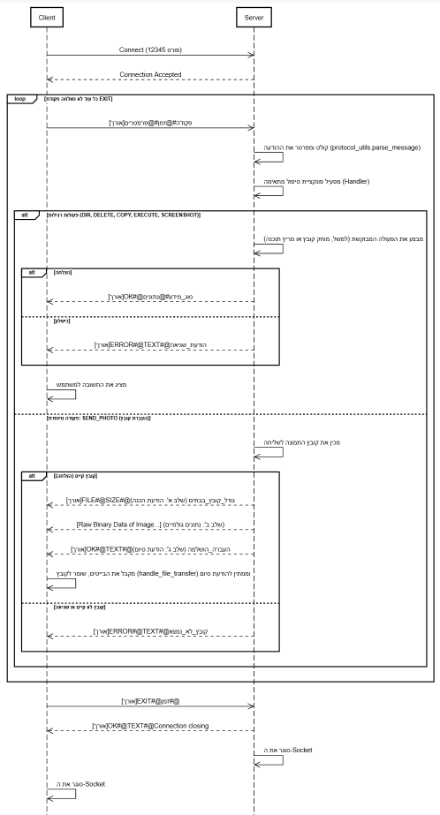
Sequence diagram

